Cucumber Report

1. General Reports
Plugin
"html:Reports/APIreport", "json:Reports/APIreport.json", "junit:Reports/APIreport.xml"

2. Allure Report
Pom.xml
<!-- https://mvnrepository.com/artifact/io.cucumber/cucumber-java -->
<dependency>
<groupId>io.cucumber</groupId>
<artifactId>cucumber-java</artifactId>
<version>6.10.4</version>
</dependency>
<!-- https://mvnrepository.com/artifact/io.cucumber/cucumber-junit -->
<dependency>
<groupId>io.cucumber</groupId>
<artifactId>cucumber-junit</artifactId>
<version>6.10.4</version>
<scope>test</scope>
</dependency>
<!-- https://mvnrepository.com/artifact/io.qameta.allure/allure-cucumber6-jvm -->
<dependency>
<groupId>io.qameta.allure</groupId>
<artifactId>allure-cucumber6-jvm</artifactId>
<version>2.29.1</version>
</dependency>

If we want to use the latest version of allure report then we should also use the same version of cucumber to avoid conflict.

Plugin

plugin = {"pretty", "io.qameta.allure.cucumber6jvm.AllureCucumber6Jvm"})

Plugin for generating the report.

Scenario
1. Run the test and generate the test results.
2. Right-click on the project (not the folder) → Click ‘Show in Local Terminal’.
3. Enter the following commands one by one:
- Specify the path to the allure-results folder.
- Specify the path where you want to store the generated report.

allure generate "C:\Users\harikrishnan.s\eclipse-workspace\AllureReport2\allure-results" -o "Downloads"

Path of the allure results folder and the path of where you want to store the report
4. To open the report, use the following command:
allure serve Downloads

5. To send the html file to someone need to convert it as a single file for that use the following commands.

allure generate --single-file allure-results

6. Now go to allure-report it will have the single html file.

Pre-requisites
1. Download and install the latest version of Node.js.
2. Verify the Node.js installation by checking its version:
node –-version
3. Install Allure Commandline globally using NPM:
npm install -g allure-commandline
4. Verify the NPM installation by checking its version:
npm –-version
5. Verify the Allure installation by checking its version:
allure –-version
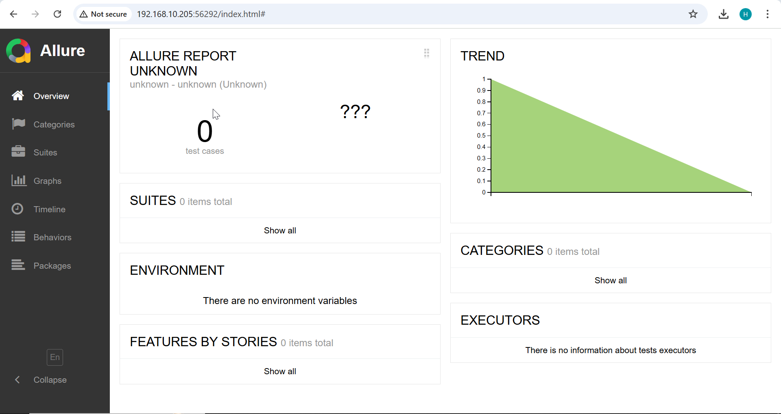

3. Extent Report
Pom.xml
<!-- https://mvnrepository.com/artifact/tech.grasshopper/extentreports-cucumber6-adapter -->
<dependency>
<groupId>tech.grasshopper</groupId>
<artifactId>extentreports-cucumber6-adapter</artifactId>
<version>2.18.0</version>
</dependency>

Plugin
plugin = "com.aventstack.extentreports.cucumber.adapter.ExtentCucumberAdapter:"

Scenario
1. Add the Extent Report dependency to your project.
2. Configure the necessary plugin for the Extent Report.
3. Create an extent.properties file and include the following details:

extent.reporter.spark.start=true
extent.reporter.spark.out=test-output/SparkReport/Spark.html
extent.reporter.spark.config=src/test/resources/extent-config.xml

extent.reporter.pdf.start=true
extent.reporter.pdf.out=test-output/PdfReport/ExtentPdf.pdf

4. Add an extent-config.xml file with the required configuration details.
<?xml version="1.0" encoding="UTF-8"?>
<extentreports>
<configuration>
<!-- report theme -->
<!-- standard, dark -->
<theme>standard</theme>

<!-- document encoding -->
<!-- defaults to UTF-8 -->
<encoding>UTF-8</encoding>

<!-- protocol for script and stylesheets -->
<!-- defaults to https -->
<protocol>https</protocol>

<!-- title of the document -->
<documentTitle>Extent</documentTitle>

<!-- report name - displayed at top-nav -->
<reportName>Automation Report</reportName>

<!-- location of charts in the test view -->
<!-- top, bottom -->
<testViewChartLocation>bottom</testViewChartLocation>

<!-- custom javascript -->
<scripts>
<![CDATA[
$(document).ready(function() {

});
]]>
</scripts>

<!-- custom styles -->
<styles>
<![CDATA[

]]>
</styles>
</configuration>
</extentreports>

5. Run the test case. Upon execution, a folder named test-output will be created, containing the PdfReport and SparkReport.
